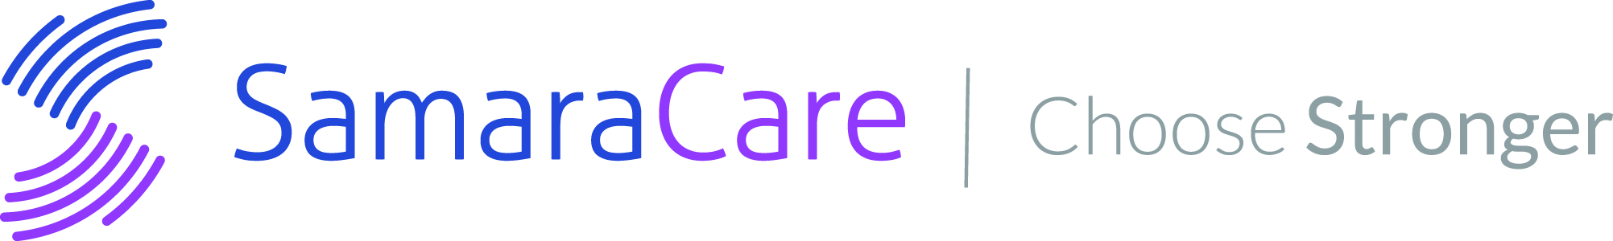

FOR IMMEDIATE RELEASE
September 23, 2019

Contact:
William B. Peterson
SamaraCare, Director of Development
(630) 357-2456 ext. 22
wpeterson@samaracarecounseling.org
samaracarecounseling.org

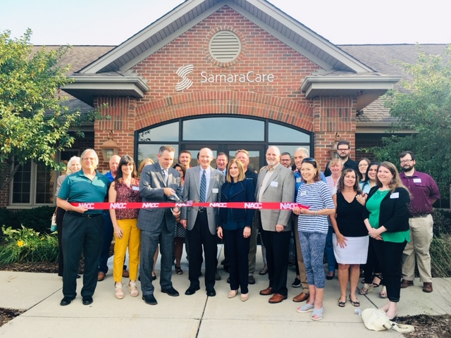

Pictured:
Naperville Chamber of Commerce members, SamaraCare board members and staff, including
in center, Kevin Coyne, Naperville City Councilman; Scott Mitchell, SamaraCare President &
CEO; Amanda Hartley, SamaraCare Board President; Bill Peterson, Director of Development.

SamaraCare celebrates grand re-opening of Naperville counseling center

Naperville, IL - SamaraCare celebrated the grand re-opening of its Naperville counseling center on Thursday, September 12, 2019, following the completion of a building expansion and remodeling project. The event featured a ribbon cutting hosted by the Naperville Chamber of Commerce, as well as an Open House for invited guests. Approximately 200 guests attended the event to view the remodeled space and interior design improvements that included new furnishings, technology improvements, branding and signage. In addition, SamaraCare unveiled an artistic donor wall honoring those who donated funds to the original 2004 building construction campaign and/or the 2018 “Growing to Serve More” building expansion and remodeling campaign.

“I thank the Naperville Chamber of Commerce and our many donors and supporters for supporting our organization and recognizing the importance of our work in the community.” stated Scott Mitchell, SamaraCare President & CEO. “I am also gratified by the personal investment that so many of our donors, have made to make our vision become a reality. The building improvements represent a special gift to ourselves and to future generations of all ages who will come to SamaraCare seeking help for mental health challenges. “
###

SamaraCare was founded in 1971 as an interfaith mental health counseling organization to address the unmet mental health needs of the Naperville community. Since then, SamaraCare has grown to become one of the largest nonprofit mental health organizations in the Chicago region, serving over 1,600 clients annually. For nearly 50 years, it has remained dedicated to providing access to quality, affordable counseling services. It pioneered the Mental Health Access Program (MHAP), which provides fee subsidies to individuals and families with financial limitations who come to SamaraCare seeking care.

